AustriaTech | June 2022
Version 1.3
  - Route Analysis and Risk Assessment
  - in preparation for the implementation of test drives with automated vehicles on roads in Austria which are publicly accessible

1 Principles and objectives 3
2 Process for route analysis and risk assessment 4
2.1 Phase 1 6
2.2 Phase 2 9
2.3 Phase 3 12
3 Appendix 15
3.1 Template for route analysis 15
3.2 Risk assessment template 17
3.2.1 General section assessment 18
3.2.2 Special section assessment 23

Principles and objectives
The present procedure for route analysis and risk assessment is an additional building block for ensuring road safety for all road users in the course of testing automated vehicles on roads which are publicly accessible. The process of risk assessment is based on the so-called Road Safety Inspection (RSI), whereby the focus is on the safety inspection of the route.
Site visits are conducted to perform the route analysis and risk assessment. If the framework conditions permit, photo and/or video documentation is to be carried out and the image material is to be made available to the BMK, the contact point and the members of the Automated Mobility Advisory Board for the best possible evaluation of the results of the route analysis and risk assessment. In any case, existing regulations, such as the Data Protection Act / the General Data Protection Regulation (GDPR) or the Road Traffic Regulations (StVO), must be complied with. Thus, in case of photo and video recordings, e.g. faces and licence plates must be unrecognisable. In addition, for example on motorways, the ban on stopping on emergency lanes, unless authorised to do so, must be complied with.
This method leads to an intensive examination of the local conditions and risks. The planned test route is extensively analysed and evaluated. The identified risks can be mitigated in further process steps by infrastructure-related, vehicle-related, organisational or other adequate precautions or measures. The aim must always be to increase road safety for all road users.
The person/s who carries/carry out the route analysis and risk assessment must be specified as the "person carrying out the analysis" in chapter 3 and must have adequate specialist expertise in the area of road transport and safety management for road infrastructure (for further information, see the Code of Practice, chapter “Route Analysis and Risk Assessment”).

Process for route analysis and risk assessment
Figure 1 shows the process of route analysis and risk assessment, the three phases of which are explained in more detail in the following chapters.
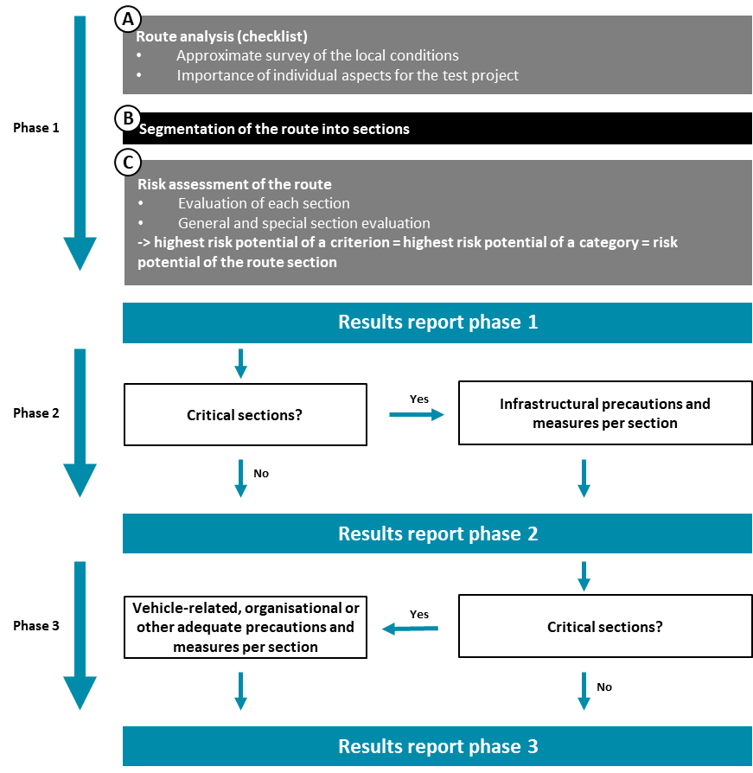
Figure 1: Process of route analysis and risk assessment (own illustration)

Figure 2 shows the logical procedure and thus the order in which the tables presented in the following chapters are to be used.

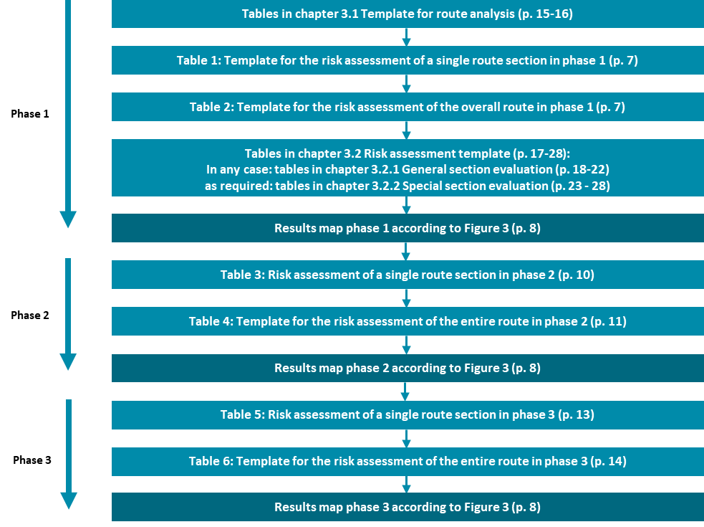

Figure 2: Process of route analysis and risk assessment according to the tables to be used (own illustration)

Phase 1

Phase 1 involves route analysis, segmentation of the route into sections, and initial risk assessment of the route.
During the route analysis, a rough survey of the local conditions takes place, which provides a comprehensive overview of all relevant characteristics of the test route. The results of this initial route analysis also provide essential clues for segmenting the route for the subsequent risk assessment by section.
When segmenting the route, the route is divided into individual sections for each significant change. The criteria from Table 1 can be used for this purpose. Further criteria for segmenting the route can be a change in the number of lanes or the road cross-section. In any case, in addition to this exemplary list, all criteria relevant for the respective route must be used.
Subsequently, the individual sections are evaluated. A general section assessment and (if relevant) an additional special section assessment are carried out for each section. The criterion in a category with the highest risk also represents the risk potential of the category. The risk potential of the section is then derived from the category with the highest risk potential and is presented in tables and in a section map.
Phase 1 concludes with a results report that must include at least the following elements:
- Description of the test track.
- Result of the route analysis (table).
- Segmentation of the route into individual sections (table and map).
- Individual risk assessment of each section of the route and presentation according to table 1 and 2, and as a map according to figure 2.
- Summary of the results.

Table 1 summarises the results of the general and special section assessment. See Annex 3.2.1 General section assessment and Annex 3.2.2 Special section assessment from page 18.
Table 1: Template for the risk assessment of a single route section in phase 1.
Section  …………….. | Category | Risk potential i
General section assessment | Facility and visibility conditions
 | Road equipment
 | Presentation of information
 | Lighting conditions
 | Maintenance and road condition
 | Climatic influences
 | Collision-mechanical hazards
Special section  assessment | Intersection area
 | Motorway junctions / interchanges
 | Unregulated crossing areas
 | Tunnel assessment
 | Bridge assessment
 | Areas with mixed traffic
 | Areas of stops of public transport
 | Loading adreas
 | Risk potential of the route section i

Table 2: Template for the risk assessment of the overall route in phase 1
Route section | Risk potential
Section 1
Section 2
Section 3
Section …
Overall risk of the route i

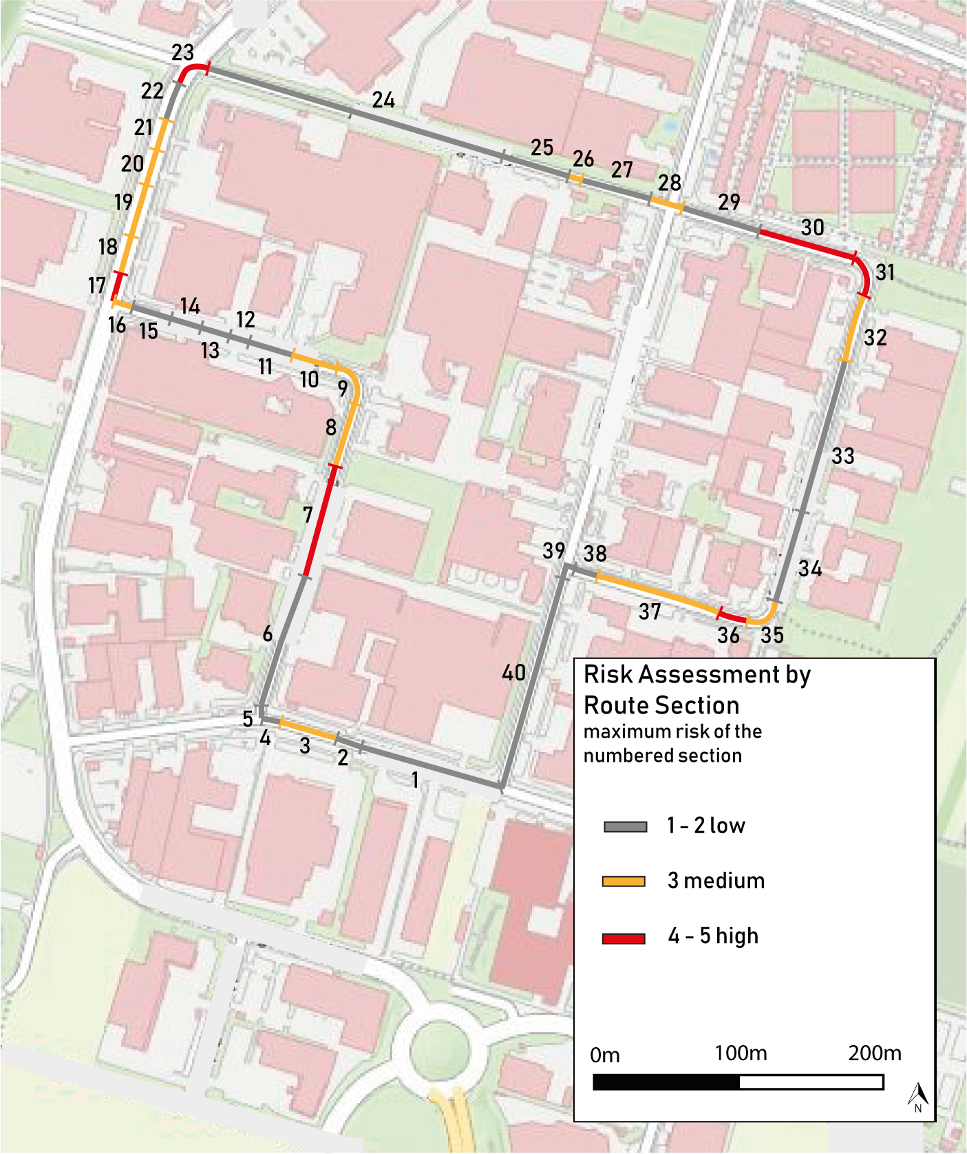

Figure 3: Example for a results map of the risk assessment by route sections
(own illustration)

Phase 2

In Phase 2, for all existing critical sections with medium (3) or high (4-5) risk, appropriate infrastructure-related precautions and measures are independently determined to mitigate the risk (mitigation measures).
Based on the risk assessment in phase 1, the following procedure results for phase 2 per route section:
- Gray areas (low risk - 1 and 2): no further consideration required.
- Yellow areas (medium risk - 3): development of infrastructure-related precautions and measures in phase 2.
- Red areas (high risk - 4 and 5): development of infrastructure-related precautions and measures in phase 2.

Examples of infrastructure-related precautions and measures include modification or expansion of the physical infrastructure, traffic lights, equipment with sensor technology or other adequate measures.
Subsequently, taking into account the defined infrastructure-related precautions and measures, a further risk assessment is carried out and its description in the results report of phase 2 (see chapter Fehler! Verweisquelle konnte nicht gefunden werden.).

The results report for Phase 2 must include at least the following elements:
- Documentation of the infrastructure-related precautions and measures for each route section.
- Individual risk assessment of each route section taking into account the mitigation measures (according to tables 3 and 4 and as a map according to figure 2).
- Summary of the results.
Table 3: Risk assessment of a single route section in phase 2
Section  …………….. | Category | Risk potential phase 1 i | Infrastructure mitigation measures i | Risikopotential Phase 2 i
General section assessment | Facility and visibility conditions
 | Road equipment
 | Presentation of information
 | Lighting conditions
 | Maintenance and road condition
 | Climatic influences
 | Collision-mechanical hazards
Special section assessment | Intersection area
 | Motorway junctions / interchanges
 | Unregulated crossing areas
 | Tunnel assessment
 | Bridge assessment
 | Areas with mixed traffic
 | Areas of stops of public transport
 | Loading areas
 | Risk potential of the route section i

Table 4: Template for the risk assessment of the overall route in phase 2.
Route section | Risk potential phase 1 i | Risk potential phase 2 i
Section 1
Section 2
Section 3
Section …
Overall risk of the route i

Phase 3

In Phase 3, for all remaining critical sections with medium (3) or high (4-5) risk, appropriate on-board, organisational, or other adequate precautions or measures are independently determined to mitigate the risk (mitigation measures).
Examples of Phase 3 precautions and measures for medium and high risk sections include:
- Consideration of vehicle-specific characteristics
- Special hazard warnings or instructions for operators for this section
- Route section is driven at lower speed
- Route section is not driven automatically
- Other adequate precautions and measures

Taking into account the defined precautions or measures, a final assessment and description of the risk potentials for the individual route sections is made.
The results report for Phase 3 must include at least the following elements:
- Documentation of the on-board, organisational or other adequate precautions or measures for each route section.
- Final risk assessment of each route section, taking into account the mitigation measures (according to Tables 5 and 6 and as a map according to Figure 2).
- Summary of the results.

Table 5: Risk assessment of a single route section in phase 3
Section  …………….. | Category | Risk potential phase 1 i | Infrastructure mitigation measures i | Risk potential phase 2 i | Vehicle, organisational or other adequate mitigation measures i | Risk potential phase 3 i
General section assessment | Facility and visibility conditions
 | Road equipment
 | Presentation of information
 | Lighting conditions
 | Maintenance and road condition
 | Climatic influences
 | Collision-mechanical hazards
Special section assessment | Intersection area
 | Motorway junctions / interchanges
 | Unregulated crossing areas
 | Tunnel assessment
 | Bridge assessment
 | Areas with mixed traffic
 | Areas of stops of public transport
 | Loading areas
 | Risk potential of the route section i

Table 6: Template for the risk assessment of the overall route in phase 3
Route section | Risk potential phase 1 i | Risk potential phase 2 i | Risk potential phase 3 i
Section 1
Section 2
Section 3
Section …
Overall risk of the route i

Appendix
Data of the person conducting the route analysis and risk assessment i:
First and last name:
Company:
Position:
Phone number:
E-Mail-Address:

Template for route analysis

Special Locations | Existing? i | Amount i | Importance for test project i
Highly frequented tourist facilities | Yes/No
Highly frequented facilities (e.g. supermarket, post office, bank, etc.) | Yes/No
Public transport junctions | Yes/No
Motorway and expressways junctions | Yes/No
Schools | Yes/No
Kindergardens | Yes/No
Retirement homes | Yes/No
Facilities for people with limited mobility (e.g. associations for the blind) | Yes/No
Exits of Public Emergency Services (Blue-Light Organisations) | Yes/No
Railroad crossings | Yes/No
Loading areas | Yes/No

Quality of data transmission / reception quality | Existing? | % of total route length
Areas without GNSS reception | Yes/No | <25% | 25%-50% | >50%
Areas without mobile phone reception | Yes/No | <25% | 25%-50% | >50%

Traffic safety | Existing? | % of total route length
Accident blackspots / accident route areas i | Yes/No | <25% | 25%-50% | >50%
High percentage of vehicles with heavy goods (greater than 10%) | Yes/No | <25% | 25%-50% | >50%
Use by agricultural vehicles, street cleaning vehicles and the like | Yes/No | <25% | 25%-50% | >50%
Probability of traffic jams / traffic flow problems | Yes/No | <25% | 25%-50% | >50%
Maximum speed limit >50km/h | Yes/No | <25% | 25%-50% | >50%
Parking spaces along the route | Yes/No | <25% | 25%-50% | >50%
On-road bike lanes in longitudinal direction (especially multi-purpose lanes) | Yes/No | <25% | 25%-50% | >50%
Physically separated bike lanes | Yes/No | <25% | 25%-50% | >50%
Areas where truck overtaking bans end | Yes/No | <25% | 25%-50% | >50%
Construction sites (planned) | Yes/No | <25% | 25%-50% | >50%

Route conditions taking the intended test vehicle into account i | Existing? | % of total route length
Route length with steep gradients | Yes/No | <25% | 25%-50% | >50%
Areas with small lane width | Yes/No | <25% | 25%-50% | >50%
Areas with low clearance height | Yes/No | <25% | 25%-50% | >50%
Areas with low bend radii i | Yes/No | <25% | 25%-50% | >50%
Areas with inadequate or no lane markings | Yes/No | <25% | 25%-50% | >50%
Temporary regulations (e.g. temporary truck driving ban or loading areas) | Yes/No | <25% | 25%-50% | >50%

Special route areas | Existing? | % of total route length
Tunnel sections and underpasses | Yes/No | <25% | 25%-50% | >50%
Bridges | Yes/No | <25% | 25%-50% | >50%
Encounter zones/play streets, etc. -> Routes with mixed groups of road users | Yes/No | <25% | 25%-50% | >50%

Surroundings along the route | Existing? | % of total route length
Urban environment | Yes/No | <25% | 25%-50% | >50%
Rural environment | Yes/No | <25% | 25%-50% | >50%
Unobstructed visual relations | Yes/No | <25% | 25%-50% | >50%
Limited visual relations | Yes/No | <25% | 25%-50% | >50%
Street canyons | Yes/No | <25% | 25%-50% | >50%
Open fields or meadows | Yes/No | <25% | 25%-50% | >50%
Forest or trees | Yes/No | <25% | 25%-50% | >50%

Risk assessment template

The "General Section Assessment" is to be performed for each section of route.
In addition, the "Special Section Assessment" is to be performed for intersection areas, highway junctions/interchanges, unregulated crossing areas, tunnels, bridges, zones with mixed traffic, bus stop areas and loading areas.
For each criterion, check the appropriate box for the identified risk potential in the assessment matrix. All individual assessments performed are part of the results reports.
The respective results are to be entered in Table 1 (if necessary also Tables 3 and 5).
Information on how to fill in the tables:
Tables in chapter 3.1: the applicable answers can be left in place and non-applicable answers can be deleted, as shown in the following example:
Example of how the correct answer should be given | Existing? | % of total route length
Maximum speed limit >50km/h | Yes | <25%
Construction sites (planned) | No
Parking spaces along the route | Yes |  | 25%-50%

Tables in chapter 3.2: the selection of the applicable answer in the tables is done by circling the number, as shown in the following example:
Example to illustrate how to select the applicable answer | Low | Medium | High
 | 1 | 3 | 5
☐ Not applicable, because i:

Alternative "Not applicable because:“
Example to illustrate how to select the applicable answer | Low | Medium | High
 | 1 | 3 | 5
☒ Not applicable, because i: | An explanation is added here as to why this criterion does not apply

The following template can be used:

General section assessment
Section: ………
Facility and visibility conditions
Impairments due to planting and vegetation | Low | Medium | High
 | 1 | 3 | 4
☐ Not applicable, because i:

Parking lane existing |  | Available space in relation to total cross section
Parking direction (for the most part) |  | Generous | Sufficient | Constricted
 | Longitudinal | 1 | 2 | 3
 | Angled | 1 | 3 | 4
 | Transverse | 2 | 3 | 4
☐ Not applicable because:

Bicycle lane or multi-purpose lane present |  | Available space i
 |  | Generous i | Sufficient  i | Constricted  i
Parking strip | No parking lane available | 1 | 2 | 3
 | Longitudinal parking | 2 | 3 | 4
 | Angled parking | 2 | 3 | 5
 | Transverse parking | 3 | 4 | 5
☐ Not applicable because:

Bicycling allowed against the one-way system |  | Available space i
 |  | Generous i | Sufficient  i | Constricted  i
Parking strip | No parking lane available | 1 | 2 | 3
 | Longitudinal parking | 2 | 3 | 4
 | Angled parking | 3 | 4 | 5
 | Transverse parking | 4 | 5 | 5
☐ Not applicable because:

Speed limit (low-ranking road network) |  | Traffic volume (cross-section in  both directions – ADT i)
V max (Maximum allowed speed) |  | Low  (<1. 000) | Medium  (1.000-5.000) | High  (>5.000)
 | Low (≤30km/h) | 1 | 2 | 3
 | Medium (31-50km/h) | 2 | 3 | 4
 | High (>50km/h) | 3 | 4 | 5
☐ Not applicable because:

Speed limit (motorways and expressways) |  | Traffic volume (cross-section  per direction - ADT)
V max (Maximum allowed speed) |  | Low (<20.000) | Medium  (20.000-40.000) | High  (>40.000)
 | Low (<100km/h) | 1 | 2 | 3
 | Medium (100-120km/h) | 2 | 3 | 4
 | High (121-130 km/h) | 3 | 4 | 5
☐ Not applicable because:

Lane reduction (low-ranking road network) |  | Traffic volume (cross-section in  both directions - ADT)
Length & announcement of the interlinking route |  | Low  (<1. 000) | Medium  (1.000-5.000) | High  (>5.000)
 | Long (>100m) & Good Announcement | 1 | 2 | 3
 | Long (>100m) & Poor Announcement | 2 | 3 | 4
 | Sufficient (≤100m) & Good announcement | 2 | 3 | 4
 | Sufficient (≤100m) & Poor Announcement | 3 | 4 | 5
☐ Not applicable because:

Lane reduction (motorway and expressways) |  | Traffic volume (cross-section per direction - ADT)
Length & announcement of the interlacing route |  | Low  (<20.000) | Medium  (20.000-40.000) | High  (>40.000)
 | Long (>400m) & Good announcement | 1 | 2 | 3
 | Long (>400m) & Poor Announcement | 2 | 3 | 4
 | Sufficient (≤400m) & Good announcement | 2 | 3 | 4
 | Sufficient (≤400m) & Poor Announcement | 3 | 4 | 5
☐ Not applicable because:

Road equipment
Phantom markings | Isolated | Rare | Frequent
 | 3 | 4 | 5
☐ Not applicable because:
Road markings | Quality of road marking |  | Not existing
 | Medium | Low
 | 2 | 4 | 5
☐ Not applicable because:

Road traffic signs (incl. alternating traffic display or alternating text display) |  | Recognisability of road signs
 |  | Medium | Low | Contradictory  Road traffic signs
Type of traffic signs | Information sign according to §53 StVO and variable message sign | 2 | 3 | 5
 | Danger signs (acc. to §50 StVO) and regulatory signs (acc. to §52) also on variable traffic signs | 3 | 4 | 5
☐ Not applicable because:

Presentation of information
„An overload" in the relevant presentation of information i | Low | Medium | High
 | 2 | 3 | 4
☐ Not applicable because:

Non-uniformity (e.g. 30 or 30km) | Low | Medium | High
 | 1 | 2 | 3
☐ Not applicable because:

Incorrect placement of traffic signs (e.g. traffic signs in the wrong place) | Low | Medium | Often
 | 1 | 2 | 3
☐ Not applicable because:

Visual guidance in bends i | Insufficient | Misleading | Not existing
 | 3 | 4 | 5
☐ Not applicable because:

Lighting conditions
Street lighting inadequate or non-existent | Inadequate | Very inadequate | Not existing
 | 2 | 3 | 4
☐ Not applicable because:

Glare, masking due to neon sign or light/shadow areas existing. | Low | Medium | High
 | 2 | 3 | 4
☐ Not applicable because:

Maintenance and road condition
Drainage and water management Insufficient | Inadequate | Very inadequate | Not existing
 | 3 | 4 | 5
☐ Not applicable because:

Insufficient road grip | Friction value i
 | Medium (0,45 - <0,59) | Low  (0,38 - <0,45) | Poor  (<0,38)
 | 2 | 4 | 5
☐ Not applicable because:

Comfort-reducing damage to the roadway such as potholes, bumps, repairs or cracks existing | Rare | Frequent | Throughout
 | 1 | 2 | 3
☐ Not applicable because:

Road safety-relevant road damage such as potholes, bumps, repairs or cracks existing | Rare | Frequent | Throughout
 | 2 | 4 | 5
☐ Not applicable because:

Climatic influences
Route-specific extreme weather events (heavy rain, snowstorm, strong gusts of wind, etc.) | Rare | Frequent | Always
 | 2 | 3 | 4
☐ Not applicable because:

Collision-mechanical hazards
Hazards due to fixed obstacles in the road (side) space, projecting edges, objects, trees, house walls, etc. | Low | Medium | High
 | 2 | 3 | 4
☐ Not applicable because:

Special section assessment
In the special section assessment, only those tables are to be used that apply to the specific section. If, for example, there is no crossing area in a section, the tables for "crossing area" in the special section assessment for this specific section are to be deleted.
In the event that none of the elements from the special section assessment (crossing area, motorway junctions / interchanges, unregulated crossing areas, tunnels, etc.) are existing in a section and thus all tables get deleted, this is to be documented accordingly in a sentence.
An assessment is to be carried out for all elements from the special section assessment that are existing in the indicated route section.

Section: ………
Crossing area (without traffic light; with traffic light; roundabout; railroad crossing)
Visibility to the left or right restricted | Visibility restriction
 | Low | Medium | High
 | 2 | 3 | 5
☐ Not applicable because:

In case of turning, bicycle crossing will be crossed |  | Visibility relations when taking a turn
Bicycle crossing | i | Good | Medium | Poor
 | Not set back | 1 | 2 | 3
 | ≥ 5m set back | 2 | 3 | 4
 | < 5m set back | 3 | 4 | 5
☐ Not applicable because:

In case of turning, pedestrian crossing will be crossed |  | Visibility relations when taking a turn
Pedestrian crossing | i | Good | Medium | Poor
 | Brought forward | 1 | 2 | 3
 | Not brought forward &  ≥ 5m set back | 2 | 3 | 4
 | Not brought forward &  < 5m set back | 3 | 4 | 5
☐ Not applicable because:

Railway vehicles existing in the crossing area | Visibility restriction
 | Low | Medium | High
 | 2 | 3 | 5
☐ Not applicable because:

Complexity of the crossing area |  | Complexity of the crossing area i
 |  | Low | Medium | High
Traffic frequency of all road users | Low (<1.000) | 1 | 2 | 3
 | Medium  (1.000-5.000) | 2 | 3 | 4
 | High (>5.000) | 3 | 4 | 5

Stop line non-existent or difficult to see | Quality of road marking
 | Medium | Low | Not existing
 | 2 | 4 | 5

No clear/difficult to understand priority rules | Comprehensibility of the priority rules
 | Medium | Low | Contradictory
 | 3 | 4 | 5
☐ Not applicable because:

Traffic light existing - short clearing times | Clearance time
 | Brief | Insufficient
 | 4 | 5
☐ Not applicable because:

Traffic light signal difficult to detect | Recognisability
 | Medium | Poor | Not recognisable
 | 3 | 4 | 5
☐ Not applicable because:

Motorway junctions / interchanges
Visibility Relations | Visibility restriction
 | Low | Medium | High
 | 2 | 3 | 5
☐ Not applicable because:

Complexity of the highway junction or interchange - entrance |  | Complexity of the motorway junction or interchange i
 |  | Low | Medium | High
Traffic frequency of all road users  (one direction of travel) | Low  (<20.000) | 1 | 2 | 3
 | Medium  (20.000-40.000) | 2 | 3 | 4
 | High  (>40.000) | 3 | 4 | 5

Complexity of the motorway junction or interchange - exit |  | Complexity of the motorway junction or interchange i
 |  | Low | Medium | High
Traffic frequency of all road users  (one direction of travel) | Low  (<20.000) | 1 | 2 | 3
 | Medium  (20.000-40.000) | 2 | 3 | 4
 | High  (>40.000) | 3 | 4 | 5

Acceleration lane |  | Traffic volume (cross-section  per direction – ADT)
Length |  | Low (<20.000) | Medium  (20.000-40.000) | High  (>40.000)
 | Long (>250m) | 1 | 2 | 3
 | Short (≤250m) | 3 | 4 | 5
☐ Not applicable because:

Deceleration lane |  | Traffic volume (cross-section per direction - ADT)
Length & announcement of the exit |  | Low (<20.000) | Medium  (20.000-40.000) | High  (>40.000)
 | Long (>250m) & Good announcement | 1 | 2 | 3
 | Long (>250m) & Poor announcement | 2 | 3 | 4
 | Sufficient (≤250m) & Good announcement | 2 | 3 | 4
 | Sufficient (≤250m) & Poor Announcement | 3 | 4 | 5
☐ Not applicable because:

Unregulated crossing areas
Lighting not sufficiently existing | Lighting
 | Inadequate | Insufficient | Not existing
 | 3 | 4 | 5

Crossing marking difficult to recognise or not recognisable | Quality of marking
 | Inadequate | Not recognisable | Not existing
 | 3 | 4 | 5
☐ Not applicable because:

Crossing markings (pedestrian crossing + block marking) difficult to recognise or not recognisable |  | Lane divider
Crossing frequency |  | Existing | Not existing
 | Low  (<500) | 1 | 3
 | Medium  (500-1000) | 2 | 4
 | High  (>1000) | 3 | 5
☐ Not applicable because:

Tunnel/Underpass

Low ADT (≤2.500) (low-ranking road network) |  | Length
 |  | <200m | 200-500m | >500m
Oncoming traffic | No | 1 | 2 | 3
 | Yes | 2 | 3 | 4
☐ Not applicable because:

High ADT (>2.500)  (low-ranking road network) |  | Length
 |  | <200m | 200-500m | >500m
Oncoming traffic | No | 2 | 3 | 4
 | Yes | 3 | 4 | 5
☐ Not applicable because:

Low ADT (≤40.000 per direction)  (highways and expressways) |  | Length
 |  | <200m | 200-500m | >500m
Oncoming traffic | No | 1 | 2 | 3
 | Yes | 5 | 5 | 5
☐ Not applicable because:

High ADT (>40.000 per direction)  (highways and expressways) |  | Länge
 |  | <200m | 200-500m | >500m
Oncoming traffic | Nein | 2 | 3 | 4
 | Ja | 5 | 5 | 5
☐ Not applicable because:

High complexity of the tunnel (highways and expressways) |  | Tunnel complexity i
 |  | Low | Medium | High
Traffic frequency of all road users  (both directions total) | Low  (<40.000) | 1 | 2 | 3
 | Medium  (40.000-80.000) | 2 | 3 | 4
 | High  (>80000) | 3 | 4 | 5
☐ Not applicable because:

Bridges
Guardrails not existing in sufficient quality or design | Guardrails
 | Existing but inadequate quality | Not sufficiently Existing
 | 3 | 5
☐ Not applicable because:

Frequent crosswinds on the roadway | Crosswind
 | Low | Medium | High
 | 1 | 2 | 3
☐ Not applicable because:

Areas with mixed traffic
High complexity of the road space |  | Complexity of the road space
 |  | Low | Medium | High
Traffic frequency of all road users | Low (<1.000) | 1 | 2 | 3
 | Medium (1.000-5.000) | 2 | 3 | 4
 | High (>5.000) | 3 | 4 | 5

Public transport stops
Dedicated stop bay without visibility restriction |  | ADT
 |  | <1.000 | 1.000-5.000 | >5.000
Speed limit in km/h | ≤30 | 1 | 2 | 3
 | 31-50 | 2 | 3 | 4
 | >50 | 3 | 4 | 5
☐ Not applicable because:

Dedicated stop bay with visibility restriction i |  | ADT
 |  | <1.000 | 1.000-5.000 | >5.000
Speed limit in km/h | ≤30 | 2 | 3 | 4
 | 31-50 | 3 | 4 | 5
 | >50 | 4 | 5 | 5
☐ Not applicable because:

No stop bay existing |  | Lane divider
Speed limit in km/h |  | Existing | Not existing
 | ≤30 | 1 | 3
 | 31-50 | 2 | 4
 | >50 | 3 | 5
☐ Not applicable because:

Loading areas
Loading areas without visibility restriction |  | ADT
 |  | <1.000 | 1.000-5.000 | >5.000
Speed limit in km/h | ≤30 | 1 | 2 | 3
 | 31-50 | 2 | 3 | 4
 | >50 | 3 | 4 | 5
☐ Not applicable because:

Loading areas with visibility restriction i |  | ADT
 |  | <1.000 | 1.000-5.000 | >5.000
Speed limit in km/h | ≤30 | 2 | 3 | 4
 | 31-50 | 3 | 4 | 5
 | >50 | 4 | 5 | 5
☐ Not applicable because:

https://www.austriatech.at/assets/Uploads/Fokusseiten/Kontaktstelle-Automatisierte-Mobilitaet/Dokumente/1b9d4c02c5/Code-of-Practice_EN_042022.pdf

